The Case: No boot device available error in Windows 7
"Help! I have a Dell Inspiron laptop that Windows 7 installed on and it always works well. But I receive “No boot device available” prompt when I start up it. Then, I press F1 to restart my computer but this message still appears. What happened to my computer? How can fix “No boot device available” error in Dell computer and boot it normally? Any advice will be appreciated!"

Possible reasons for “No boot device available” error
Generally speaking, “No boot device available” error happens out of the following reasons:
- Boot from disk that doesn’t contain operating system.
- MBR or boot sector on the bootable disk is corrupted.
- The bootable disk is physically damaged
- You compute is infected with virus.
And this error may appear with different message like “No boot device – insert boot disk and press any key”, “Boot Device Not Found”. Please install an operating system in your hard disk” or “No Boot Device Found. Press any key to reboot the machine.”

Fix “No boot device available” in Windows 7/8/10 effectively
After realizing the possible causes for boot device not available, it’s time to see how to fix it with useful ways.

Fix 1. Check boot order and reset BIOS settings to default
To ensure that you boot from right bootable hard drive, you can press certain key to enter BIOS interface while restarting to check boot order. If the disk that you boot computer from is not the right one, press “+” or “-” to set the bootable hard drive as the first in boot order. After that, save changes and restart computer to see whether the error disappears. If the error still exists, try to reset BIOS to default settings by steps given below:
1. Turn off your computer and wait for a while.
2. Restart the computer and press certain key to enter BIOS Setup menu.
3. On the BISO Setup interface, press certain key to select and load the BIOS Setup Default settings.
4. Save changes exit and follow the prompt to restart computer.
PS.: If you are unsure about the key to enter BIOS, you can refer to the user manual of your computer.

Fix 2. Perform a hard reset
If you still meet No boot device available error, you can try to perform a hard reset to restore functionality. Here are detailed steps:
1. Turn off your computer. Remove all external peripheral devices from your computer.
2. Remove AC adapter and battery from your computer.
3. Press and hold the power button for about 15 seconds to drain all the residual energy.
4. Put the battery back and plug the AC adapter into your computer.
5. Turn on your computer to see if it boot normally.

Fix 3. Run Startup Repair with Windows installation disc
To fix “No boot device available” error automatically, you can turn to Windows Startup Repair. Look at the following steps:
1. Insert your Windows installation disc to your computer and boot from it.
2. In the Install now screen, click “Repair your computer”.
3. In the System Recovery Options window, select “Startup Repair”.

Fix 4. Run Bootrec commands with Windows installation disc
If Startup Repair cannot solve the error, you can try to run Bootrec commands to fix MBR and boot sector within the following steps:
1. Boot computer from Windows installation disc and choose “Command Prompt” in the System Recovery Options window.
2. In Command Prompt window, input command lines below and press Enter after each.
- bootrec /fixmbr
- bootrec /fixboot
- bootrec /scanos
- bootrec /rebuildbcd
3. Exit from Command Prompt interface and restart your computer.

Fix 5. Fix damaged MBR without Windows installation disc
If the MBR of your system hard drive is damaged and you have no Windows Installation disc, you can turn to a third party safe and useful tool – AOMEI Partition Assistant Standard. It owns Make Bootable Media and Rebuild MBR functions. Thus, you can use it to create a bootable device with itself embed. Then, you can boot the Windows 7 computer from the created bootable media and rebuild MBR.
To rebuild corrupted MBR, free download AOMEI Partition Assistant Standard and refer to the detailed steps presented in the following context.
Download Freeware
Win 10/8.1/8/7/XP
Secure Download
1. Connect a USB drive to a working computer. Install and run AOMEI Partition Assistant Standard. Choose “Make Bootable Media” and follow the wizard to continue.

2. After creating a bootable USB drive successfully, insert it to the computer that “No boot device available” error appears and boot from it.
3. You’ll see the main interface of AOMEI Partition Assistant Standard. Right-click the system hard drive and choose “Rebuild MBR”.
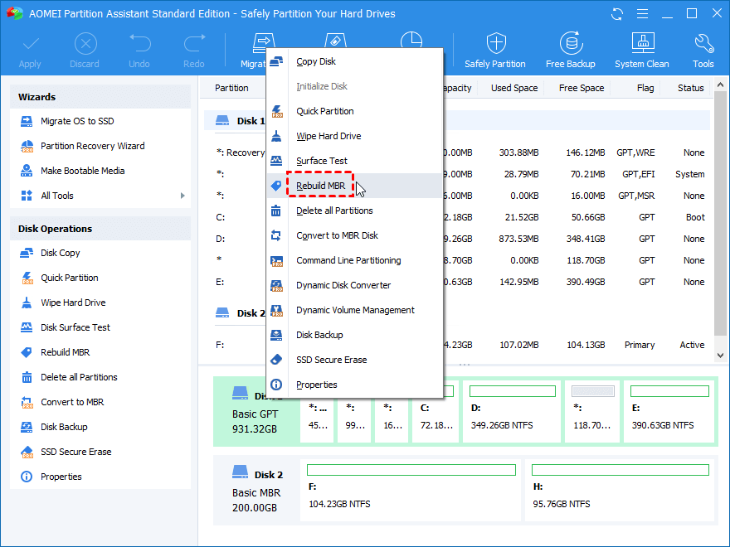
4. In the pop-up window, choose the type of MBR for the current operating system.
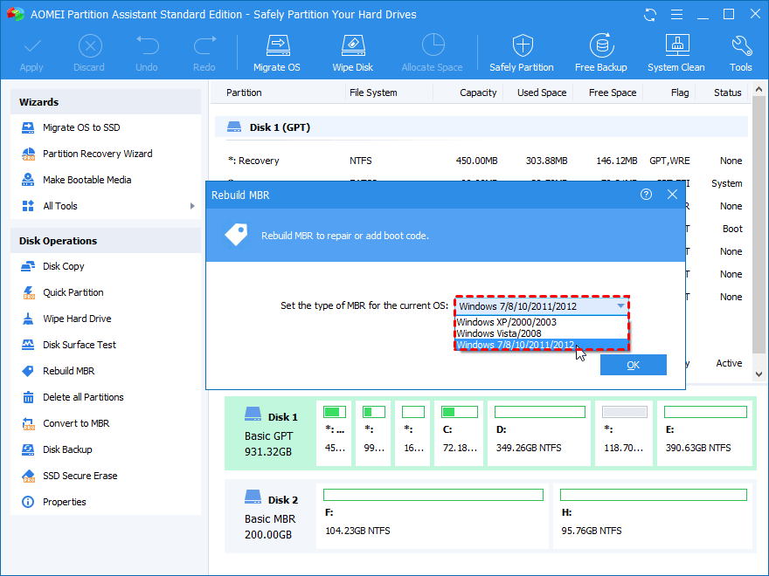
5. Back to the main interface, click “Apply”>“Proceed” to perform this task.
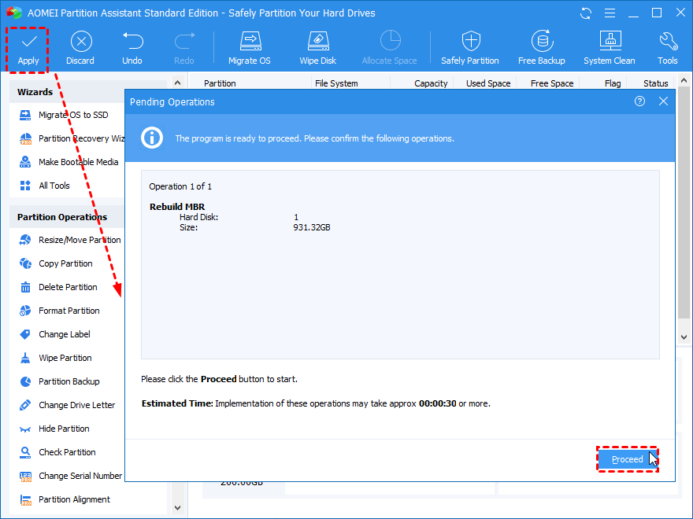
Notes:
- AOMEI Partition Assistant Standard is with high compatibility, which can work with Windows 10/8.1/8/7, XP, and Vista.
- Apart from fixing MBR, this software enjoys many other functions like wiping hard disk drive. And you can get more advanced features like cloning system disk, if you upgrade it to Professional version.

Conclusion
When you are trapped in boot failure with “No boot device available” error in Windows 7/8/10, find out the most proper one among fixes presented above to fix this error. If you are still unable to boot Windows computer successfully, try to check the bootable hard drive or run anti-virus software.
https://www.diskpart.com/windows-7/no-boot-device-available-windows-7-0310.html

ow to Fix Computer No Boot Device Available Error?
Background
If your computer pops out message ”No Boot Device is Available” error, there are some problems on your windows system, but no need to worry about that, this article will show you how to fix”no bootable device is available” error for totally free if you are seeing this no bootable device error on Dell HP ACER ASUS TOSHIBA LENOVO in Windows 10 8.1 or Windows 7 computer.

Table of Contents
- What happened when your computer says No Boot Device Available?
- Causes of Computer No Boot Device Available Error
- How to fix Computer No Boot Device Available Error Problem?
  - Check or reset the boot order on your PC.
  - Fix no boot device available by resetting the BIOS configuration
  - Fix “no boot device” error with Troubleshoot
  - Fix no boot device available error due to active partition error(tested)
  - Check, Repair or Reinstall Computer Operating System.
  - Check or restore MBR sector from your boot hard disk.
  - Run antivirus software or format your hard disk to clear the virus
- Recover the data on your computer

What happened when your computer says No Boot Device Available?
When your computer pops out a message says no boot device available error often means the computer operation system is not available to find the bootable hard disk, so it can not start to boot, so if you want to know how to fix it, you need to figure out why your computer system can not find the boot device.
Here are some causes, you can check if your computer is at the same situation.
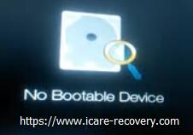 Fix no boot device available error

Causes of Computer No Boot Device Available Error

1. The computer just has been misled to boot from an unbootable hard disk or device
If you attached an external hard drive or USB and wrongly set it as a boot device, or you used to change your PC boot device order, these actions may lead to no boot device available error. In this situation, you can check your boot device order in BIOS mode.

2. The computer internal hard disk gets jammed/damaged or corrupted somehow
When your internal hard disk get jammed or damaged somehow, your computer may also reports that no boot device available error. You can check the disks status and running diagnosis.

3. The computer's boot hard disk MBR sector has corrupted somehow
The MBR sector is a hard disk that contains operating system files and drives required to start a computer. Therefore, once this drive is damaged, such PC “boot device not found” issues will happen.

4. The Operating System has changed configuration settings or damaged disk
Normally “no bootable device available” issue is caused by operating system errors. For instance, your OS updated its system files or experienced file losses when it frozed? I wouldn’t deny that those situations may occur during daily use. Doesn’t matter what is the cause of it, check your OS files and folders might be a solution to it.

5. The computer infected with virus
Trojan is the biggest nightmare for any internal hard disk and it can damage the hard disk MBR sector, OS files and folders, as well as internal hard disk and even more somehow you will have to deal with it eventually. We truly hope it have not done any harm.
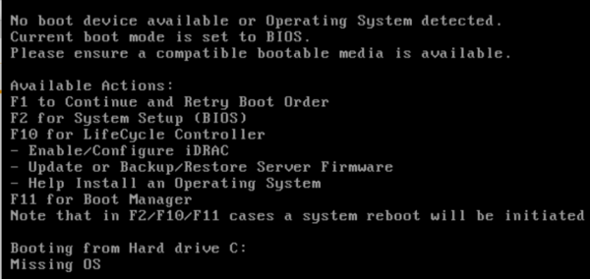 how to fix no boot device available error

How to fix Computer No Boot Device Available Error Problem?

1. Check or reset the boot order on your PC.
First, you can check or reset the boot order on your computer system, steps are as follows:
Step 1: Turn on your computer and press "F2" button to switch to BIOS mode.
Step2. Click "BIOS Setup Utility" option bar and select "Advanced BIOS Features".
Step3. Highlight "Hard Disk Boot Priority" area simply check or reset your bootable hard disk on top of the boot device list.
Step4. Press "Esc" to re-start your computer. Generally, your computer will operate well beyond any of your expectations. when “no boot device available”happens, it often means you set a wrong boot disk.

2.Fix no boot device available by resetting the BIOS configuration
Step1: Go to BIOS mode by pressing “F2”.
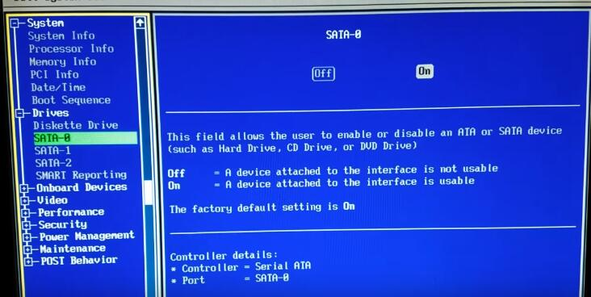
Step2: Make sure the “SATA-0”, “SATA-1”, “SATA-2” all on, if there are off, computer cannot find the boot drive.

3.Fix “no boot device” error with Troubleshoot
The second tool you can try is Troubleshoot.
Step1: Insert the Widows 10 bootable installation DVD. Click the “Repair your computer” on the left corner of computer screen.
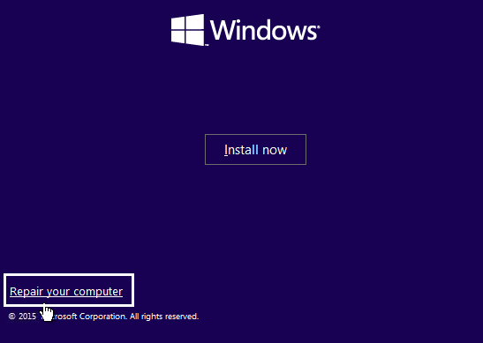
Step2: click “Troubleshoot”, and enter “Advanced options”.
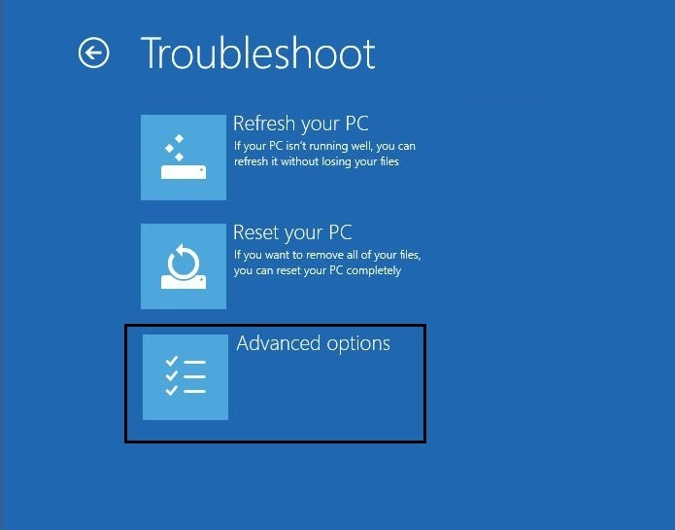
Step3: click “click Automatic Repair or Startup Repair” in the advanced options. Wait for a while, after this process, restart your computer.

4. Fix no boot device available error due to active partition error.
If there is more than 1 active partition that boots the system, then Windows does not know which one to boot. This may happen due to your using of Disk Management or other disk mange software to adjust the disk partitions before the error happens, the problem may exist on your hard disk.
How to fix active partition error?
1. You can take your disk out and insert in on another computer. (Or use Diskgenius usb bootable edition)
2, Check how many active partitions are there on the disks. If there is more than one active partition, set the rest except the c drive inactive. (use DiskGenius which shows as following photo and use its "set inactive")
3, Keep the c drive as active only, and the error can be fixed.
Why? Active partition is set as bootable partition which contains operation system. When other partition is set as active, system cannot find the boot partition so there will be a boot failure.
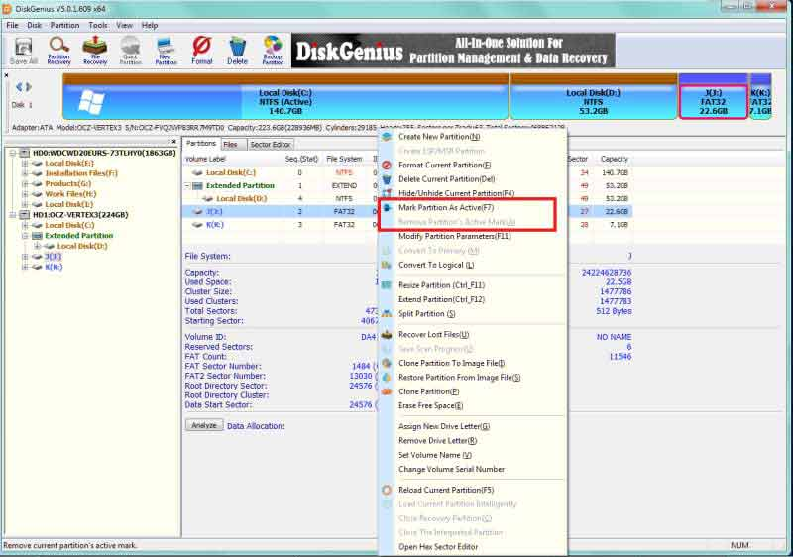
Also read: 3 ways to set partition active with freeware

5. Check, Repair or Reinstall Computer Operating System.
After these steps, if your computer no boot device available error is not solved, you can check the operating system files and folders. If the problem happened because of unexpected deletion, try to recover them first with our undelete file recovery software. If they can’t be restored, try updating or reinstalling your operating system to see whether the same “no boot device available “error message pops.

6. Check or restore MBR sector from your boot hard disk.
There is another possibility that your no boot device available error is caused by bad MBR sector on your boot hard disk. MBR is master boot record, check and restore your hard disk MBR sector will help you repair it. Command line can help you solve this.
Step 1: Backup the MBR by a command:
“dd if=/dev/sda of=/path-to-save/mbr-backup bs=512 count=1” (“path-to-save/mbr-backup” is the path where you want to save mbr-backup)
Step 2: Restore the MBR by a command:
“dd if=/path-to-get/mbr-backup of=/dev/sda bs=512 count=1” (“path-to-get/mbr-backup” is the path where you have the mbr-backup stored.)

7. Run antivirus software or format your hard disk to clear the virus
And your“boot device not foundr”error may also caused by virus infectious, you can run a antivirus software or format your disk to clean the virus.

Recover the data on your computer
What can you do when your device is not accessible? iCare Data Recovery Free is 100% freeware for a inaccessible device recovery that you may download it here.
Plus Most of the solutions may format your data on the disk, if you want to make sure the safety of your data, you can use a professional data recovery tool to restore your data from your unbootable hard disk.
Notice: Choose a read-only program, which will do no harm to your data.
https://www.icare-recovery.com/howto/how-to-fix-computer-no-boot-device-available-error-problem.html

